Antonio Rosado

Prof. Chien

IOOP Section #4

Lab #1

**By submitting this work, I certify that this assignment is my own work, and that I have not copied in part or whole from online sources or plagiarized the work of other students.**

**1.9**

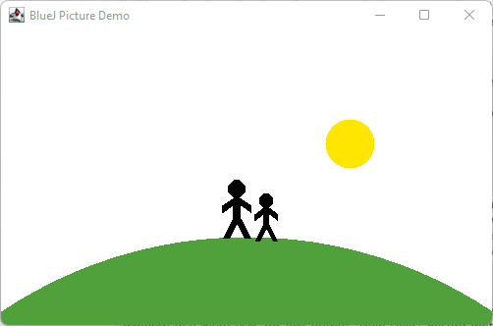

**1.20**

**1.30**

The predefined date types in Java consist of integer numbers, real numbers, and some other data types. They are as follows:

byte – 8 bits of digital information that consists of numbers; is 4 times smaller than an integer. Typically used to preserve memory in large arrays.

short – 16 bits of digital information that consists of numbers; a short integer and is two times smaller than an integer. It is used similarly to a byte with the only difference being size.

int – 32 bits of digital information that consists of numbers; an integer. Is used for basic and default integer data interpretation.

long – 64 bits of digital information that consists of numbers; a long integer. Long is typically used when a range of values longer than int is desired to be used.

float – A single-precision floating point that is used to store decimals and or fractional numbers and uses 4 bits. Since float’s value ranges are unlimited, it should NOT be used for exact values.

double – A double-precision floating point that is used to store decimals and or fractional numbers and uses 8 bits. Essentially used in similar cases as float, it’s just larger.

char – A single character that is stored in 2 bits.

boolean – Data that stores only “true” or “false” values in 1 bit.

**1.31**

0 - int

“hello” - string

101 - int

-1 - int

true - boolean

“33” - string

3.1415 - double

**1.32**

private String name;

**1.33**

public void send(String parameter)

**1.34**

public int average(int avg1, int avg2)

**1.35**

This book I’m reading is an object because it’s a physical thing, whereas the class is “Book” as this object is a “book” by theory. The object or book I’m reading is Objects First with Java.

**1.36**

No, an object cannot have several different classes because objects are dependent on classes. Classes are essentially the outline that create objects. Meaning that all classes and objects are exclusive to one another. This is because a class is logical whereas objects are physical, the class plays the creator, and the object is what’s created.